|  |  |
| --- | --- |
| **Ex.No:13** | **Simulate the bouncing ball using pygame** |
|  |

***Aim:***

To develop a python to simulate the bouncing ball using pygame.

***Algorithm:***

|  |  |
| --- | --- |
| **Step 1:** | Import and initialize pygame with pygame.init() |
| **Step 2:** | Create a graphical screen (Surface) with pygame.display.set_mode(). |
| **Step 3:** | Load ball image and define the rectangle around the image. |
| **Step 4:** | Inside the infinite loop, move the ball by (2,2) pixels (speed) in x,y coordinates |
| **Step 5:** | If the ball goes out of the screen boundary, reverse the direction of speed |
| **Step 6:** | Fill the screen with black, before displaying the next position of the ball to avoid the trail of the ball visible in the animation. |
| **Step 8:** | Draw the ball in its next position on the screen using Surface.blit() method. |
| **Step 9** | The pygame.display.flip() method makes everything we have drawn on the screen |

**Program:**

import sys

import pygame

pygame.init()

size = width,height = 320, 240

speed = [2, 2]

black = 0, 0, 0

screen = pygame.display.set_mode(size)

clock = pygame.time.Clock()

ball = pygame.image.load("ball.png")

ballrect = ball.get_rect()

while 1:

clock.tick(30)

for event in pygame.event.get():

if event.type == pygame.QUIT:

sys.exit()

ballrect = ballrect.move(speed)

if ballrect.left < 0 or ballrect.right > width:

speed[0] = -speed[0]

if ballrect.top < 0 or ballrect.bottom > height:

speed[1] = -speed[1]

screen.fill(black)

screen.blit(ball, ballrect)

pygame.display.flip()

**Output:**

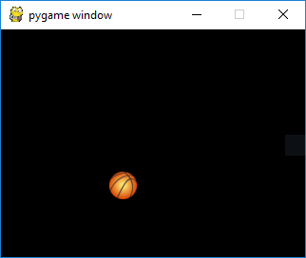

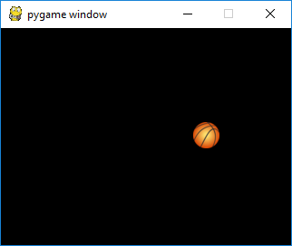

***Result:***

Thus the python program Find simulate the bouncing ball using pygame was developed and tested successfully.